Discover the hidden secrets to
United Church Camps
October 4-6, 2019, times TBD
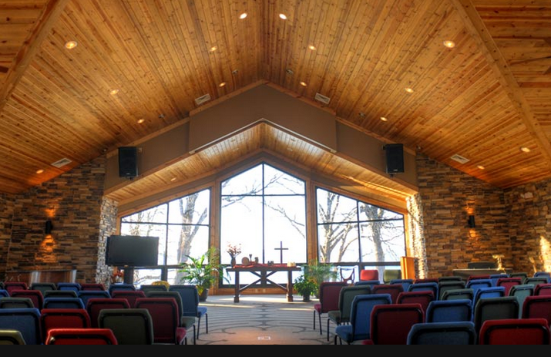
Sunday Worship, at Pilgrim Center Chapel, overlooking the lake
Work Camp Weekend at
Pilgrim Center
- Open to all members, ages 12-103.
- Regardless of age or abilities, there will be work for you
- Accommodations available for families and groups of friends (enjoy the enhancements provided by the Campital Campaign)
- Please join us for fun and fellowship, as we work together providing community service to Pilgrim Center camp.
- See the camp and enjoy the facility
- Free to ALL members
**Please contact Sue Biese or Gary Vander Linden with questions and
interest in attending

